Exercise 3.2

1. Load the data into a data frame.

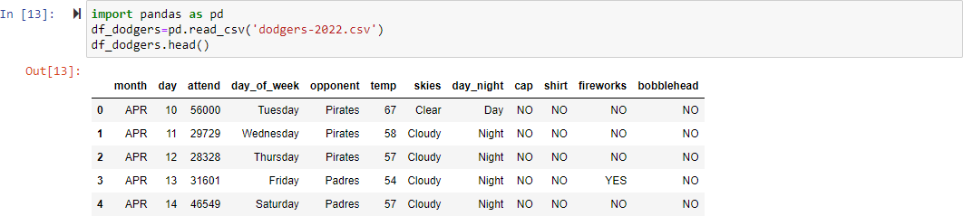

1. Check the average attendance based on the day of the week.

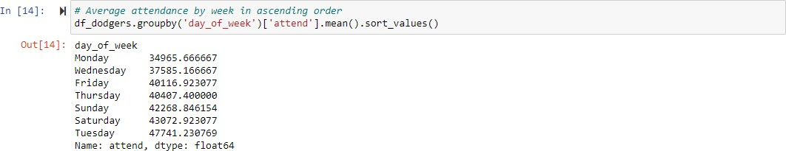

1. Check the average attendance based on the opponent.

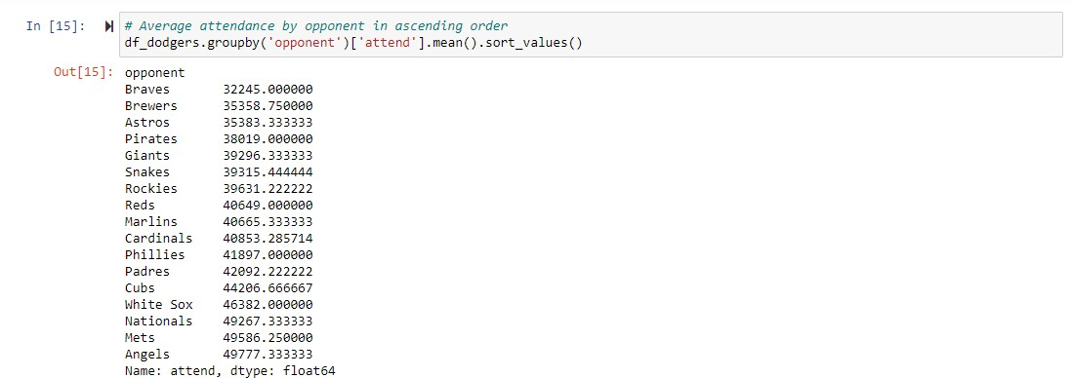

1. Check the average attendance based on skies.

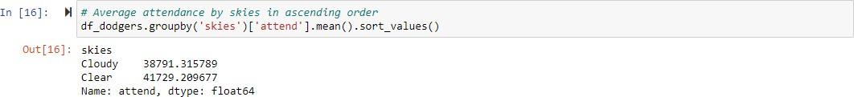

1. 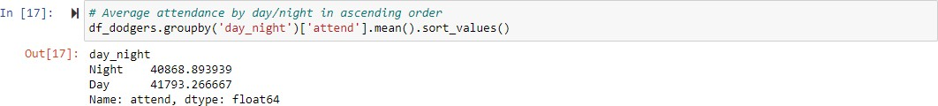Check the average attendance based on day/night

Based on the above stats it seems that the chances of the attendance are high when dodgers play against Angels/Mets/Nationals (as the avg. attendance is high when they play them) on a Tuesday (surprisingly the average attendance is high on Tuesdays) anytime (as there's only a little difference in avg. attendance between day and night) and when the skies are clear. I ignored the fields cap, shirt, bobble head and fireworks as I assume that they may not have any effect on a match.